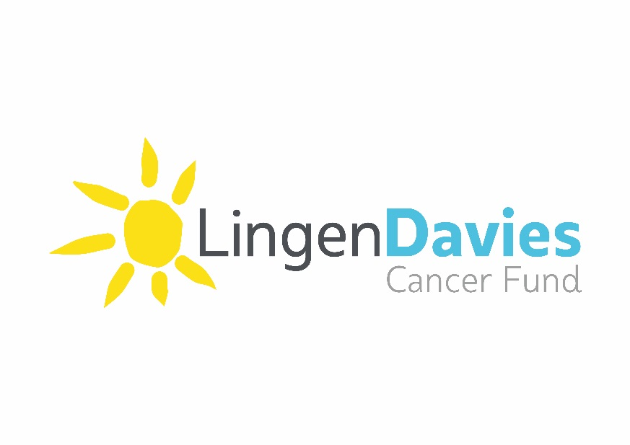

Registered Charity Number 1160922

**VIRGIN MONEY LONDON MARATHON   
Sunday 21st April 2024**

**APPLICATION FORM**

|  |  |  |  |  |  |  |  |  |  |  |  |  |  |  |
| --- | --- | --- | --- | --- | --- | --- | --- | --- | --- | --- | --- | --- | --- | --- |
| **Personal details:** | | | | | | | | | | | | | | |
| **Title** |  | | **First Name** | |  | | | | **Surname** | |  | | | |
| **Address** |  | | | | | | | | | | | | | |
| **Postcode** |  | | | | | | | | | | | | | |
| **Email** |  | | | | | **Home phone** | |  | | | **Mobile** | | |  |
| **Date of birth** | |  | | | | | | | | | | | | |
| **Employer** | |  | | | | | | | | | | | | |
| **Job Title** | |  | | | | | | | | | | | | |
| Have you applied for a public ballot place for London Marathon 2024? **(Yes/No)** | | | | | | | | | | | |  | | |
| Have you run the London Marathon before? **(Yes/No)** | | | | | | | | | | | |  | | |
| **Emergency contact:** | | | | | | | | | | | | | | |
| Name |  | | | Contact number | | |  | | | Relationship | | |  | |
| **Tell us more…:** | | | | | | | | | | | | | | |
| How did you hear about the work of Lingen Davies Cancer Fund? | | | | | | | | | | | | | | |
|  | | | | | | | | | | | | | | |
| Why have you chosen to run for Lingen Davies Cancer Fund? | | | | | | | | | | | | | | |
|  | | | | | | | | | | | | | | |
| How do you plan to raise (and exceed) the sponsorship target of £2,000? | | | | | | | | | | | | | | |
|  | | | | | | | | | | | | | | |
| How much do you believe you could raise? | | | | | | | | | | | | | | |
|  | | | | | | | | | | | | | | |
| Where did you see places advertised? | | | | | | | | | | | | | | |
|  | | | | | | | | | | | | | | |

**Application Process and Conditions**

The Lingen Davies Cancer Fund in its absolute discretion will allocate places depending upon your association with the charity, and your ability and commitment to raise money for Lingen Davies. Please answer all questions fully as this information helps us to determine who will be offered a place, to ensure that the place is used to the best possible effect.

* Closing date for applications is **30th June 2023**, you will be notified week commencing 10th July 2023 whether you have been successful.
* If you apply, you are pledging to raise a minimum of **£2,000** for the Lingen Davies Cancer Fund (excluding Gift Aid and fund matching), and that the total amount raised is paid to the charity by **1st June 2024**.
* If you are successful, you will receive a Lingen Davies running vest/t-shirt. Please indicate what size you will require (please circle) **S M L XL**
* If you choose not to run you will need to inform the charity before **10th January 2024**. If you choose not to participate after this date you will be held liable for the minimum sponsorship.
* If you have to withdraw from the event (due to injury, sickness or personal circumstances) after the 10th January 2024 please contact Lingen Davies Cancer Fund **before the day of the run**. In these instances your place may be deferred to the following year and you agree to abide by the terms and conditions that Lingen Davies Cancer Fund publishes for the subsequent event. Your sponsorship will not be required until the year you participate. You need to let the charity know as soon as possible so that arrangements can be put in place.
* You must be at least 18 years old on the day of the run to take part.
* You take part in the event at your own risk and you are responsible for ensuring that you are medically fit to compete, seeking medical advice if necessary.
* You must agree that your image can be used to promote the work of the charity and to promote the event.

I have read and agreed to the application process and conditions

Signature………………………………………………………………………….. Date…………………………………………………….

Please return your completed form to: [fundraising@lingendavies.co.uk](mailto:fundraising@lingendavies.co.uk) or post to: **Fundraising Office, Hamar Centre, Royal Shrewsbury Hospital, Mytton Oak Road, Shrewsbury, Shropshire, SY3 8XQ**

**For more information please contact 01743 492396**